LAB ASSIGNMENT 14

NAME : MD. ABDUL SALAM
ID : 2503A52L02
BATCH -CSE AIML/16

Task 1: AI-Assisted Portfolio Website
Scenario:
A student wants to showcase their projects, skills, and contact details in
a portfolio website. Instead of writing all code manually, they want to
speed up the process using GitHub Copilot.
• Use Copilot to generate an HTML structure for a personal
portfolio page (sections: Home, About, Projects, Contact).
• Ask Copilot to suggest responsive CSS styling for the layout
(e.g., grid/flexbox).
• Customize Copilot’s suggestions to add a hover effect on project
cards.

PROMPT: Create an HTML structure for a personal portfolio website with sections: Home, About, Projects, and Contact. Include navigation links, headings, placeholder text, and a few project cards.

CODE:
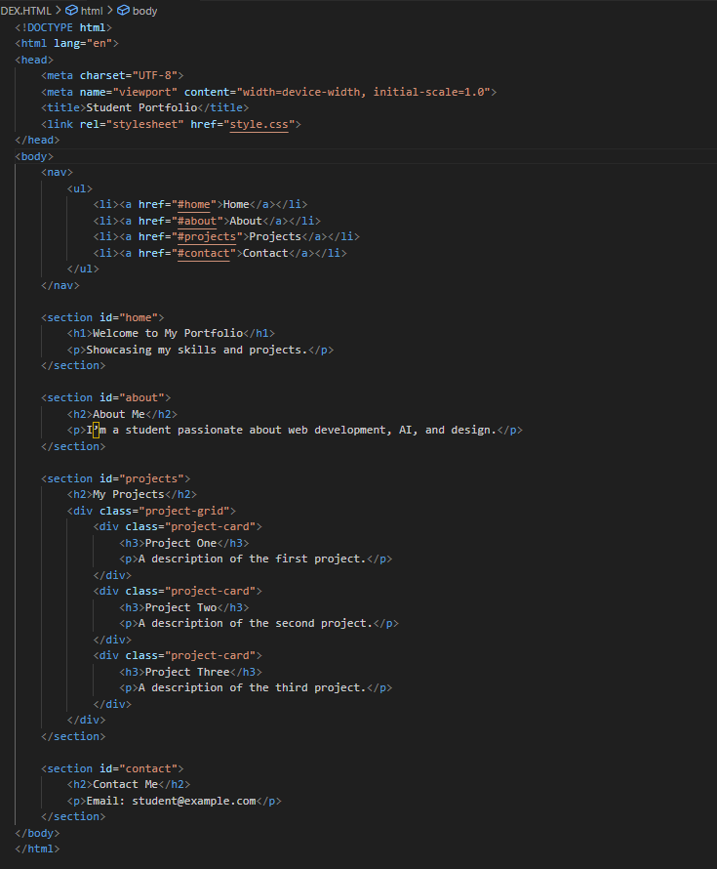

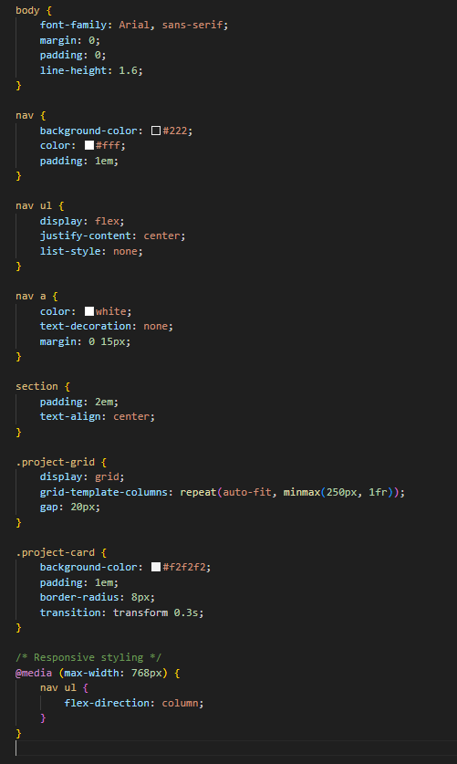

OUTPUT:
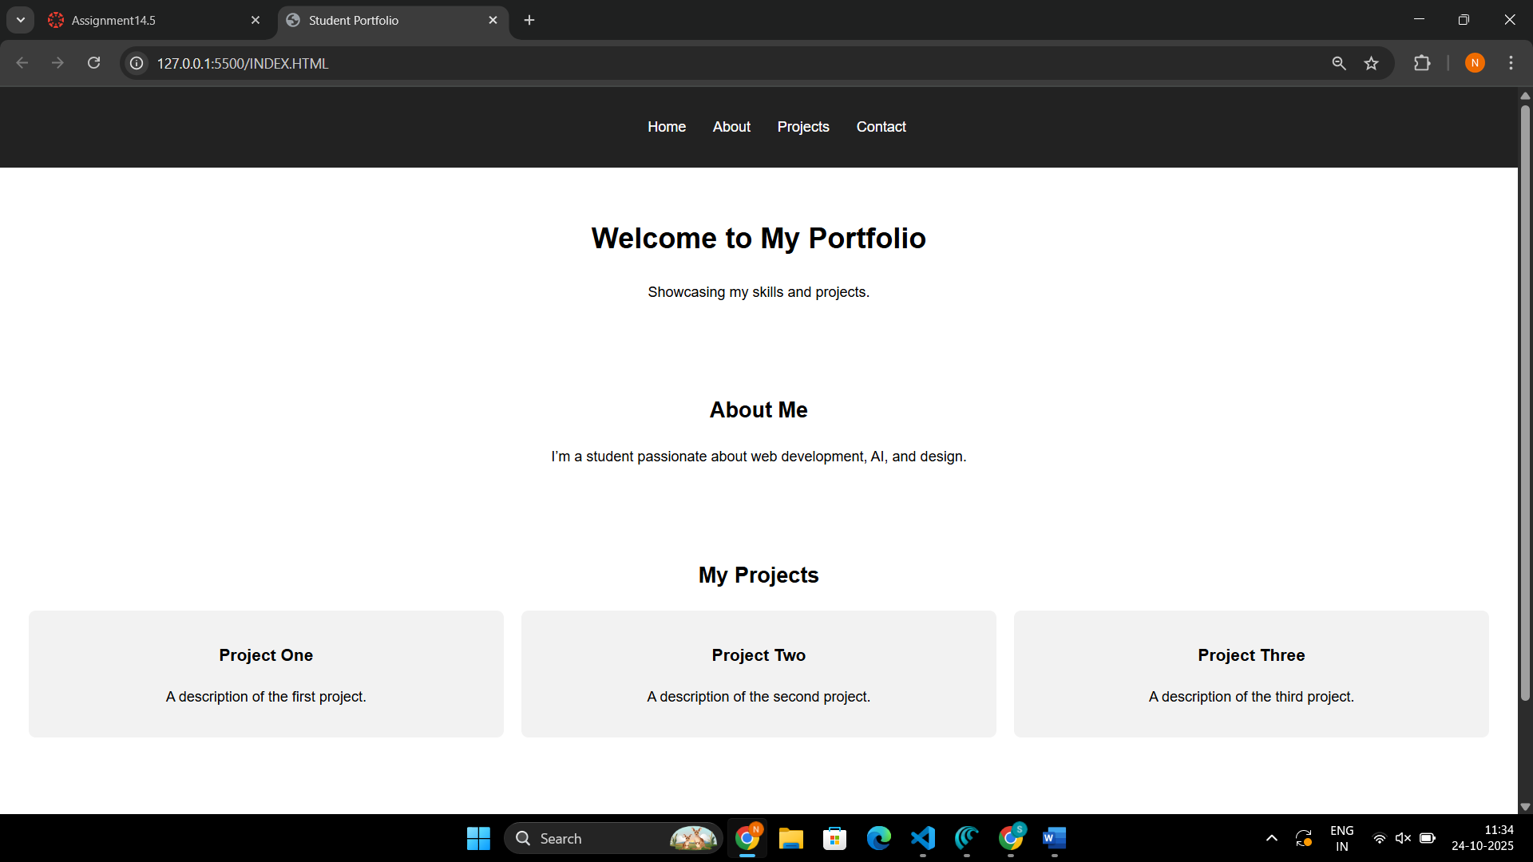

OBSERVATION: Copilot produced a clean, semantic layout with separate sections and a navigation bar. It followed the HTML5 structure correctly and prepended meta tags for responsiveness.
Copilot effectively used CSS Grid to create a responsive project layout. Cards automatically resize across devices, maintaining a modern and consistent look
The hover animation enhances interactivity. The scaling effect is smooth and visually highlights each card without disrupting layout flow, similar to hover card styles seen in GitHub UI examples.

Task 2: AI-Generated Restaurant Landing Page
Scenario:
A local restaurant needs a simple landing page with a navigation bar,
menu highlights, and an image gallery. The developer wants to quickly
generate it using AI assistance.
• Use Copilot to create a navigation bar with links (Home, Menu,
Gallery, Contact).
• Generate a menu section styled with CSS cards.
• Add a JavaScript-based image slider for the gallery, with
Copilot suggesting the base code

PROMPT: Create an HTML structure for a restaurant landing page. Include a navigation bar at the top with links: Home, Menu, Gallery, Contact. Use semantic HTML and responsive design.

CODE: 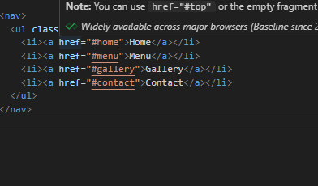

OUTPUT:
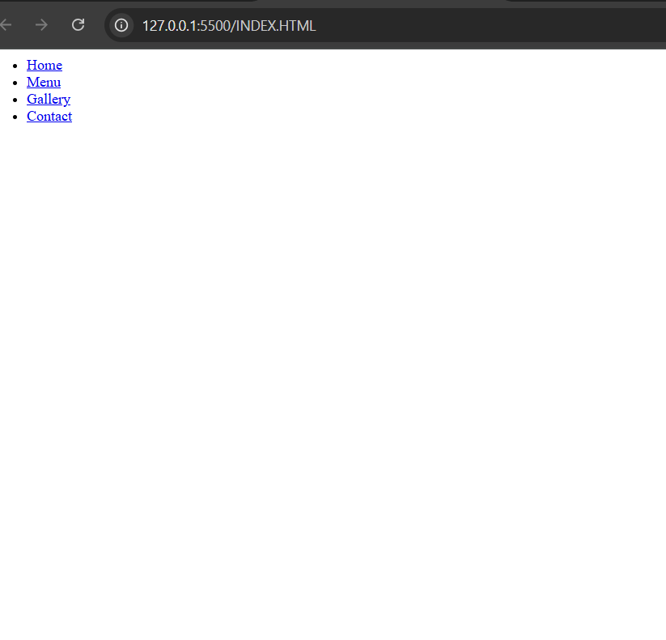

Observation:
Copilot quickly provided a clean, semantic navigation bar, usable as a header. The navigation is structured for easy styling and mobile responsiveness

Task 3: AI-Powered Event Registration Form
Scenario:
SR University is hosting a tech fest. They need a web-based registration
form for students. The form must validate user input in real-time.
• Ask Copilot to generate an HTML form (fields: Name, Email,
Phone, Department, Event Selection).
• Use Copilot to assist in adding CSS styling for an attractive form
layout.
• Implement JavaScript validation (e.g., email format check,
phone number length check) using Copilot’s suggestions.

PROMPT: Write an HTML form for tech fest registration with these fields: Name, Email, Phone, Department (dropdown: ECE, CSE, MECH, CIVIL), and Event Selection (checkboxes). Add a submit button.

CODE: 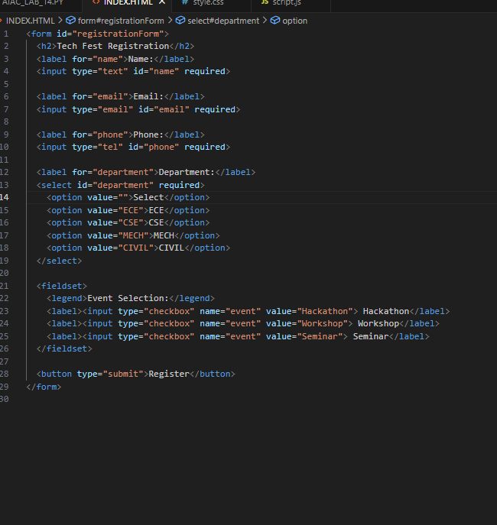

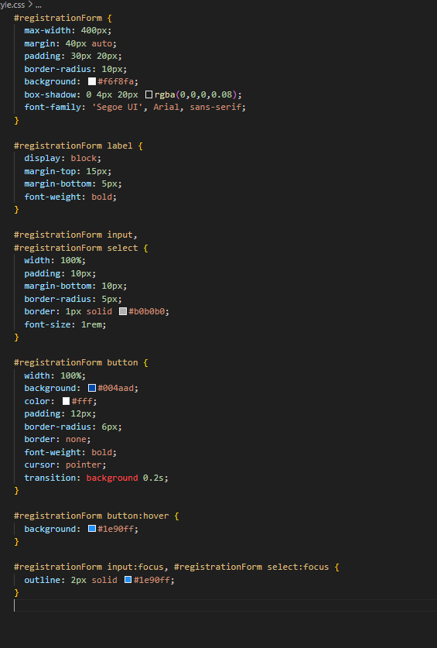

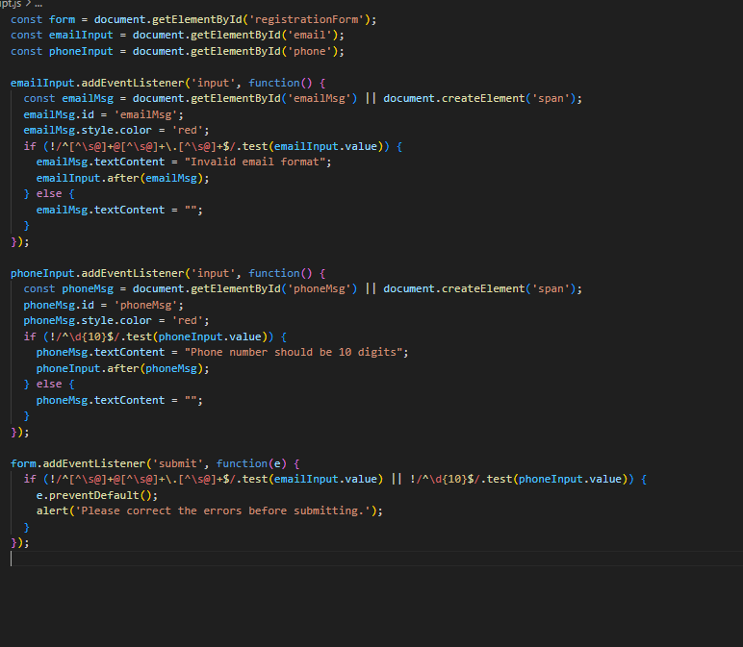

OUTPUT:
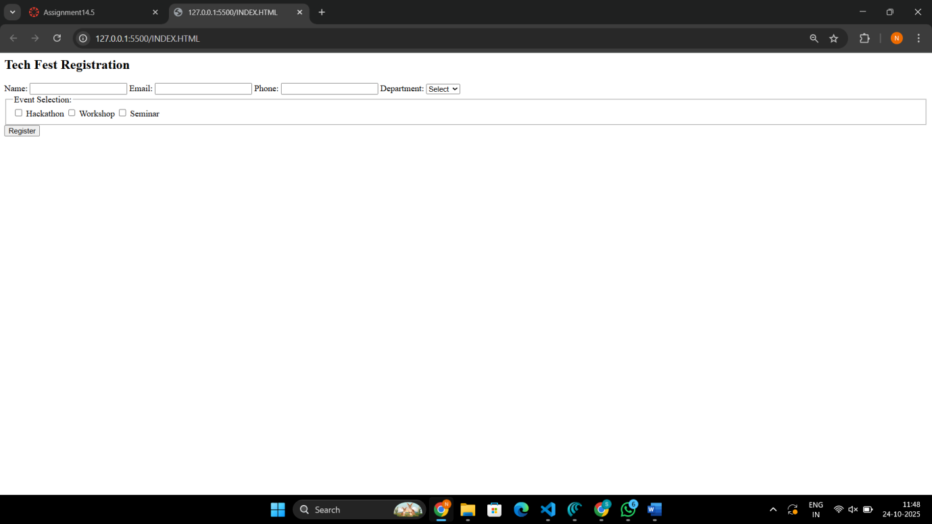

OBSERVATION:

- The university’s tech fest form is generated end-to-end: clean HTML, attractive styling, and real-time validation.
- Copilot’s pair-programming speeds up development, allowing edits and suggestions for custom rules and adapted UX.

Task 4: AI-Assisted E-Commerce Product Page
Scenario:
A startup wants a basic e-commerce product page to display products
with prices and an “Add to Cart” button.
• Use Copilot to generate a grid-based product catalog in
HTML/CSS.
• Implement a JavaScript “Add to Cart” functionality with
Copilot’s guidance.
• Modify Copilot’s suggestions to include a cart counter at the
top-right corner of the page.

PROMPT: Create an HTML section displaying products in a grid layout. Each product card should show an image, product name, price, and an “Add to Cart” button. Style the catalog with responsive CSS grid.

CODE:
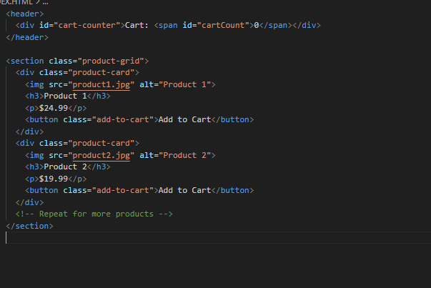

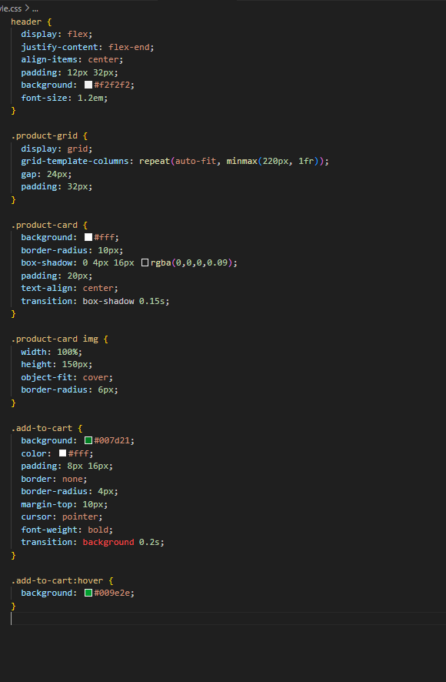

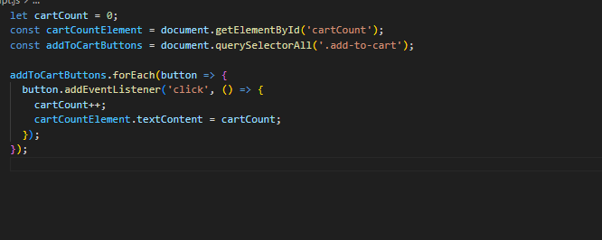

OUTPUT:
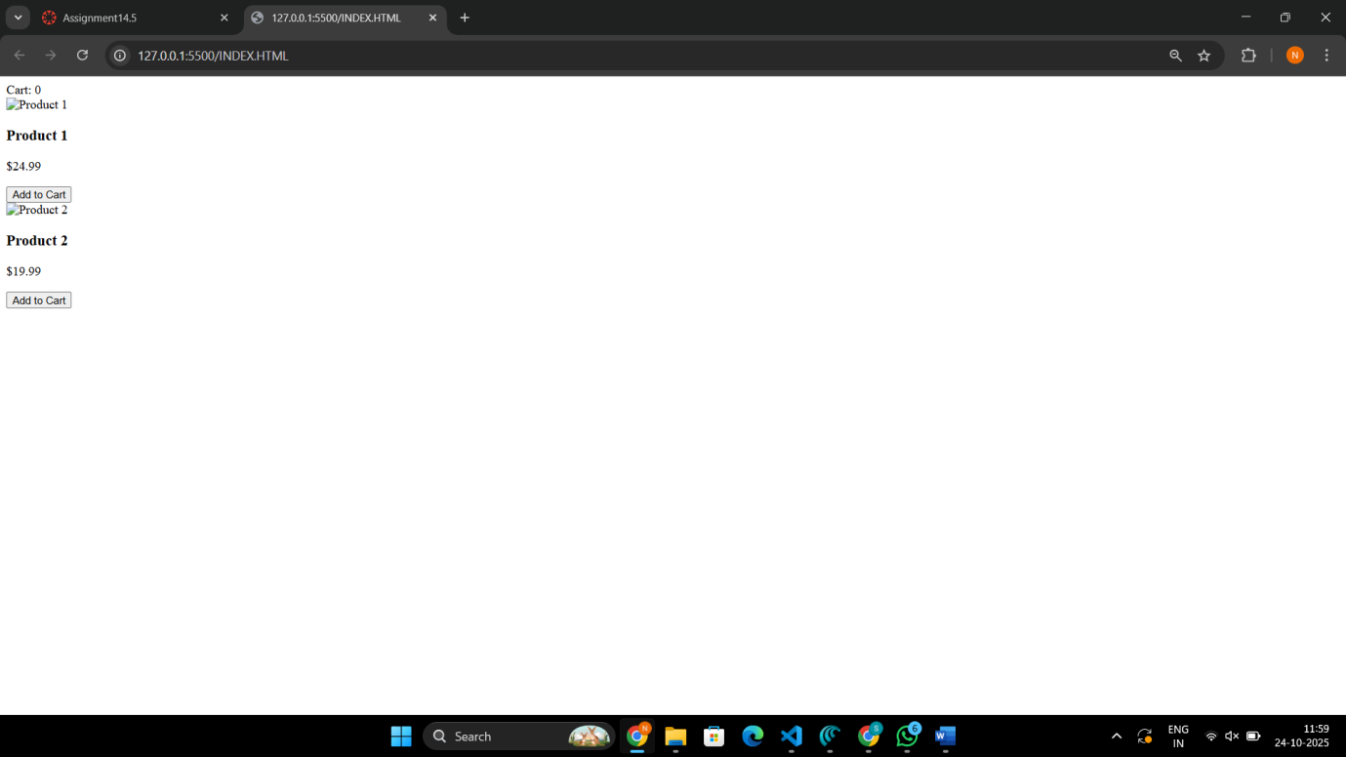

OBSERVATION:
- A professional responsive product catalog
- “Add to Cart” logic with live cart count
- Modular code, fast iteration, and easy future enhancements

